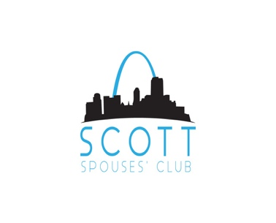
Dear Community Partner,

We are excited to announce that the Scott Spouses Club’s Annual Trivia Night and Silent Auction Scholarship Fundraising Event will take place February 29, 2020.

Over the years, this amazing event has allowed us to help military dependents reach their dreams of higher education. Our 2019 trivia night event raised over $10,000. Last year we were able to award 16 military dependent scholarships totaling $16,000. This year we would like to be able to support even more of these high school students and military spouses as they start or continue their education.

The Scott Spouses Club is currently seeking companies willing to support this important charitable event in one of the following ways:
EVENT CONTRIBUTORS
These contributors will receive special recognition at our event, as well as through our marketing and event promotion. Significant contributors will also be given tickets to attend the fundraiser as our special guests.

Our contribution levels are as follows:
PLATINUM TIER: $3000 *This level will receive a full table for 8 guests with snacks and drinks included.
GOLD TIER: $1500-$2999 *This level will receive a full table for 8 guests with snacks included.
SILVER TIER: $1000-$1499 *This level will receive 4 tickets to this event with drinks included.
BRONZE TIER: $500-$999 *This level will receive 2 tickets to this event

TRIVIA ROUND SPONSORS
$200. Sponsorship is limited, as we only have 10 sponsorship opportunities available. You will be featured in our event program, as well as in social media advertising for the event.

ITEM OR BASKET DONORS
The items donated will be auctioned off during the silent auction portion of the evening. Examples from the past contributions include merchandise of any kind, gift cards for merchandise or services, gift baskets filled with items, tickets to athletic or cultural events, theme parks, area shows, gift certificates for dining, shopping, and other retail interests.

We are aware that you receive many request for donations, but we hope that you find that donating to our organization is a way to impact various schools, community partners, and military families throughout Belleville, Fairview Heights, Shiloh, Mascoutah, and O’Fallon areas.

We are a tax exempt 501 (c)(3) organization and we will be happy to supply you with a donation receipt for tax purposes. Our tax ID is 30-0250590

We appreciate your support in helping us celebrate the tradition of awarding financial scholarships and supporting our local community. For more information about any of these opportunities or if you have any questions please contact us at fundraising@scottspouseclub.com or by phone 402-770-4660.

Sincerely,
Eve Mitchell and Jessica Manfre
SSC Fundraising Chairs.

*This is a private organization. It is not part of the department of defense or any of its components and it has no government status.

